# Lab 3

## Assigning IP Address to a Network (with router / manual)

1. Make a network similar to this and open the router settings.

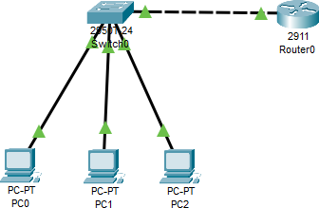

1. 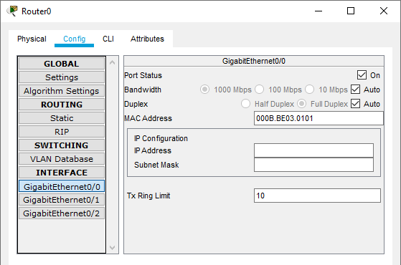Open config and go to the port which is in use (GigabitEthernet0/0 or 0/1 or 0/2)
2. In the “IP Address” field, type the following IP address: **192.168.1.1** and click enter, it’ll automatically add a relevant subnet mask.

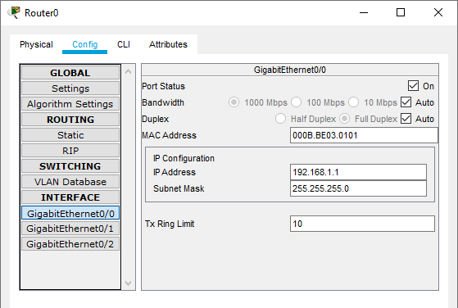

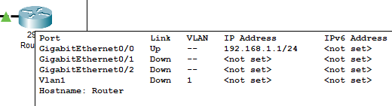

1. Now, click on the end device (PC/Laptop) and open its setting and go to “desktop”.

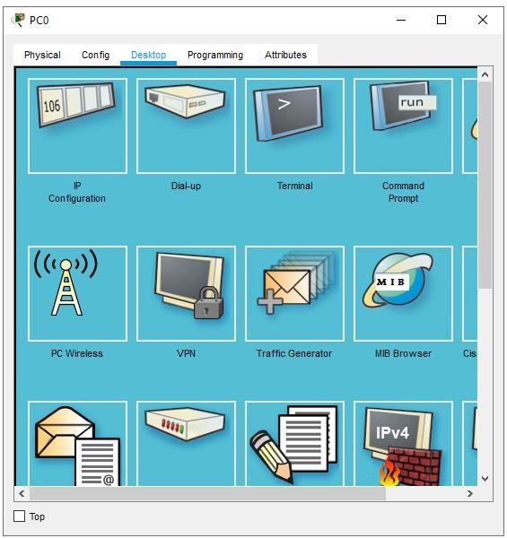

1. From here, open the first option “IP Configuration”

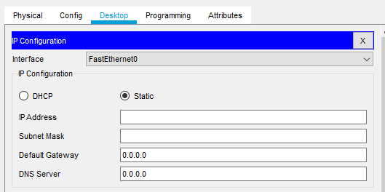

1. Now, in here type the IP Address of the network “192.168.1.0” but the IP can’t be same as the “Router’s IP Address”

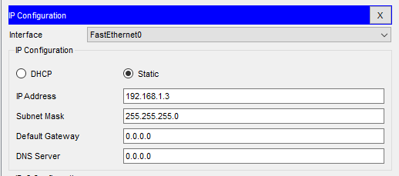

1. In the Command prompt, type ‘ipconfig’ and check if the IP is assigned or not IP will be displayed in “IPV4”.

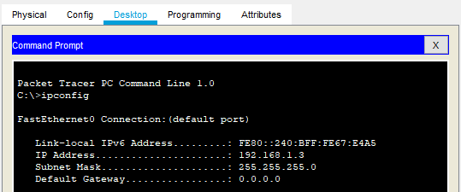

1. Repeat the Steps 5 to 9 for all the End-Devices to assign them IP manually.
2. Afterwards, you can check if the IP is assigned to devices, (either by hover, or command prompt)

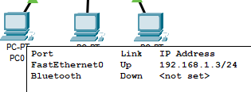

1. 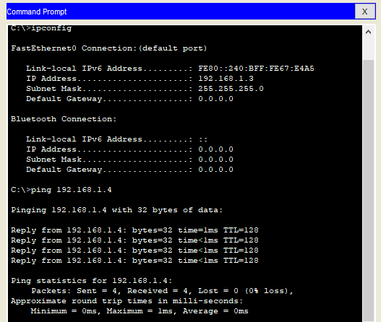Now to check if we can transfer message between end-devices or not, just open any end-device and open its Command Prompt, and type “**ping**” and afterwards type the **ip-address** of **target device**.

**Task 1;**

# Lab 3 - Task

Design the network of "Lab-7" or “Lab-8” (2-3 rows of computers) Use: Switch, Router, & End-Devices like Laptop/PC

Assign them IP Address (Static/Manually) of any Network (or you can use network **192.168.1.0**)

